NUMPY PROGRAM

Aim
To study the NumPy library and perform basic array operations such as creating one-dimensional and two-dimensional arrays, zeros, ones, an identity matrix, and a sequence of numbers.

Algorithm
- Start the program.
- Import the NumPy library using import numpy as np.
- Create and display a 1D array containing elements from 1 to 5.
- Create and display a 2D array with 2 rows and 3 columns.
- Create and display a $3×3$array filled with zeros.
- Create and display a $2×4$array filled with ones.
- Create and display a $3×3$identity matrix.
- Generate and display numbers from 0 to 10 with a step size of 2 using np.arange().
- Display all the arrays and generated numbers.
- Stop the program.

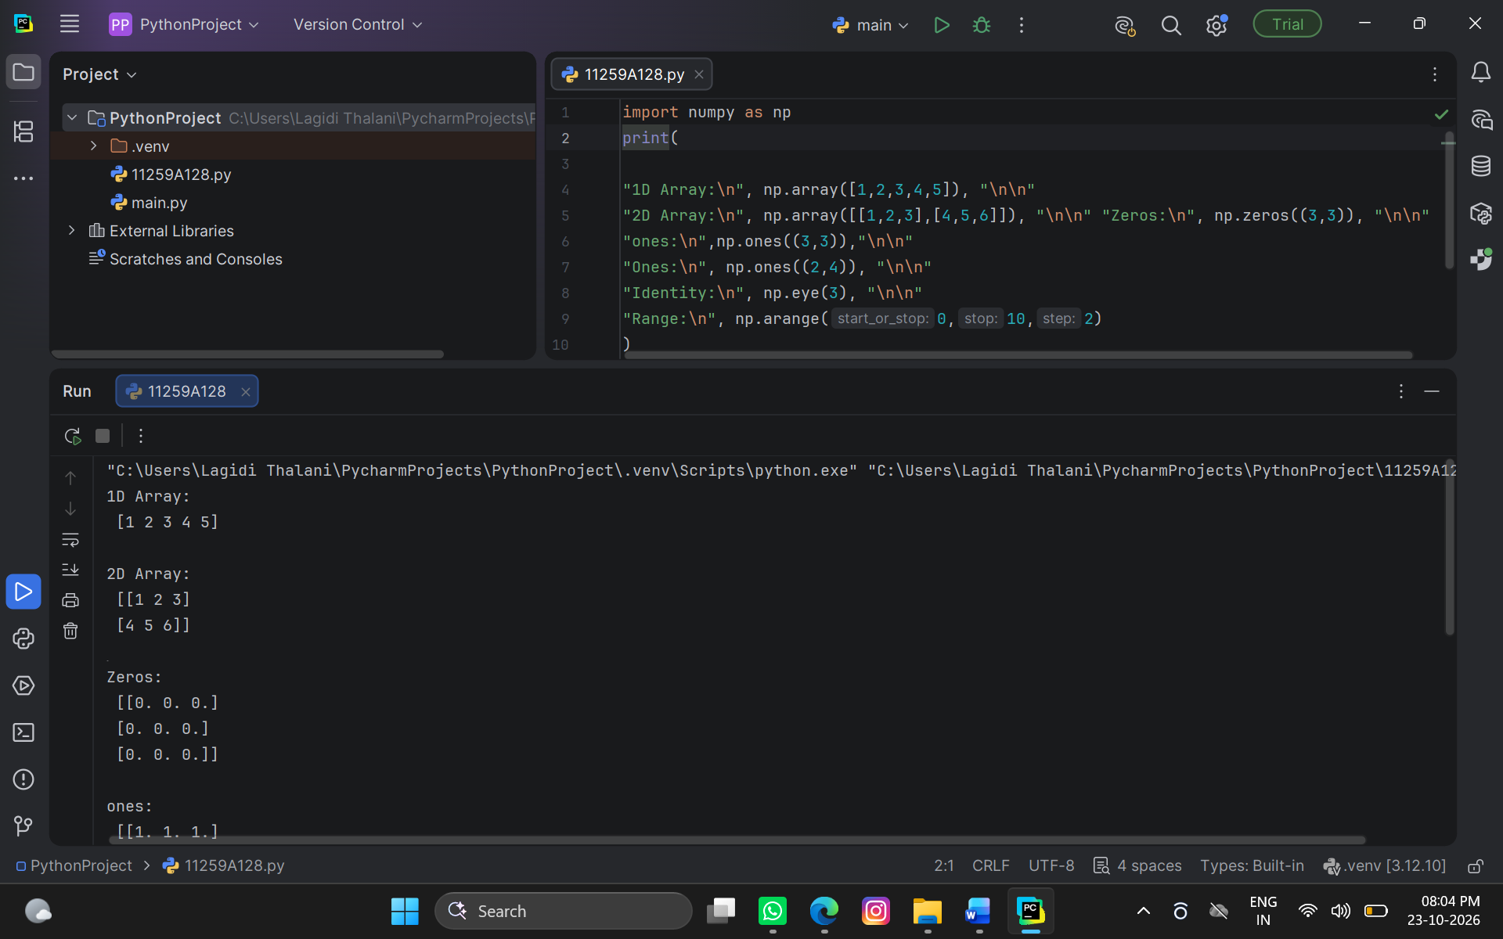

Result
Thus, the NumPy library was imported successfully, and one-dimensional arrays, two-dimensional arrays, zero arrays, one arrays, an identity matrix, and a sequence of numbers were created and displayed successfully.

AIM
To perform data preprocessing on a given dataset by handling missing values, removing duplicate records, and converting categorical data into numerical form.

Algorithm
1. Start the program.
2.Import the required libraries, such as Pandas and NumPy.
3. Load the given dataset using pd.read_csv().
4. Display the first few rows of the dataset.
5. Check for missing values using isnull().sum().
6. Handle missing values by filling them with suitable values or removing incomplete records.
7. Identify and remove duplicate records.
8. Convert categorical data into numerical form if required.
9. Display the cleaned dataset.
10. Stop the program.

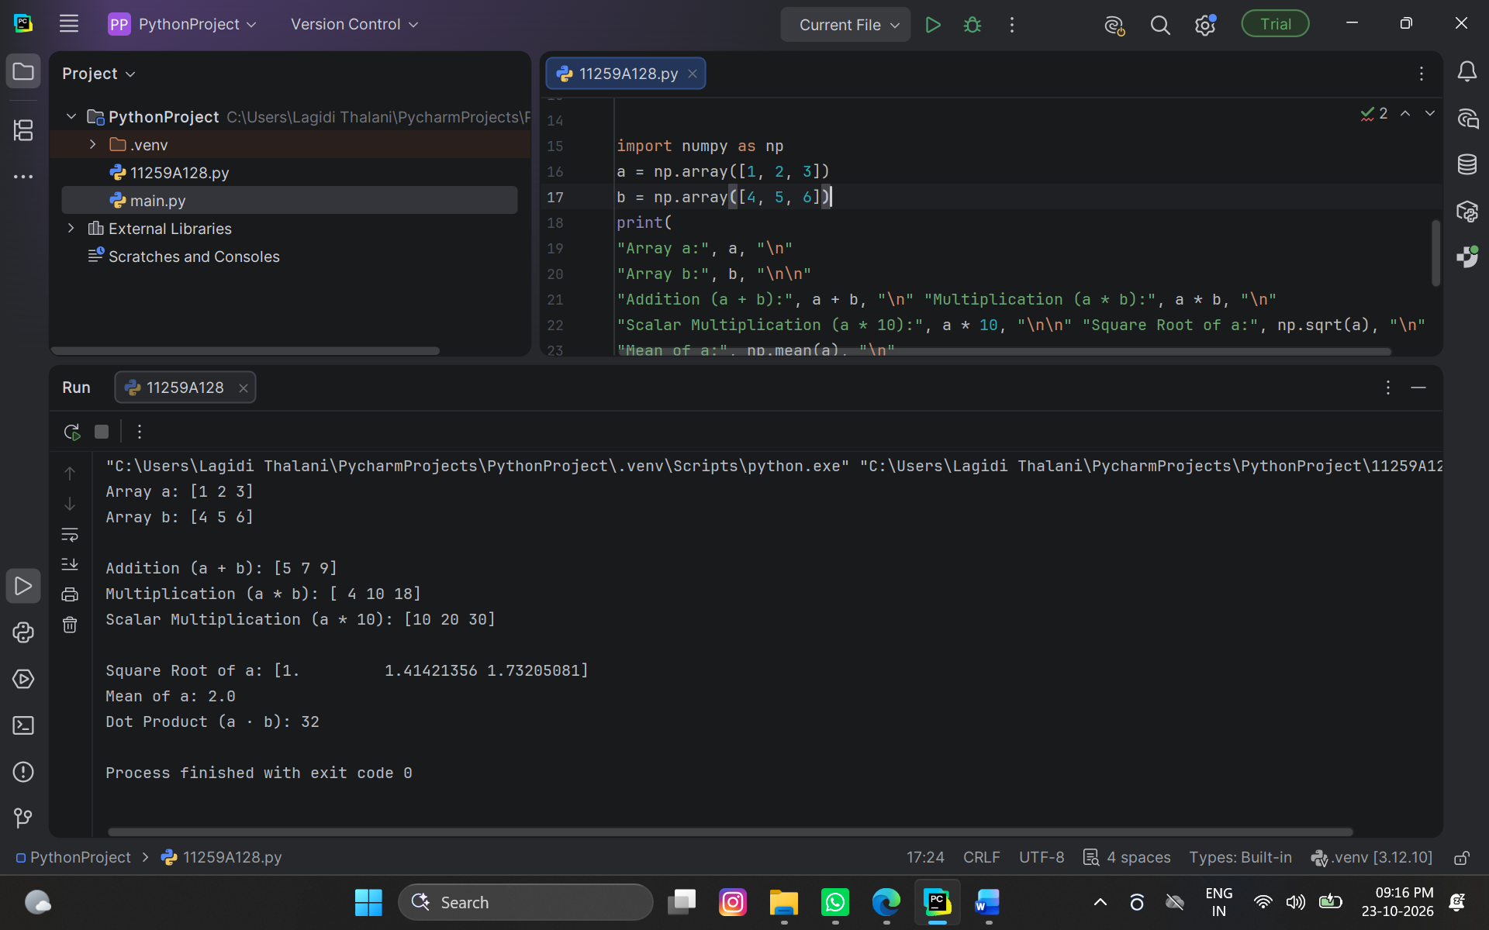

Result
Thus, data preprocessing was performed successfully, and the dataset was cleaned by handling missing values, removing duplicates, and converting categorical data where necessary.

Aim
To split a given dataset into training and testing sets and evaluate the model using cross-validation.

Algorithm
1. Start the program.
2.Import the required libraries from Pandas and Scikit-learn.
3. Load the dataset and separate the input features and target variable.
4.Split the dataset into training and testing sets using train_test_split().
5.Train the machine learning model using the training dataset.
6.Predict the output using the testing dataset.
7.Apply cross-validation using cross_val_score().
8.Calculate and display the average cross-validation score.
9.Stop the program.

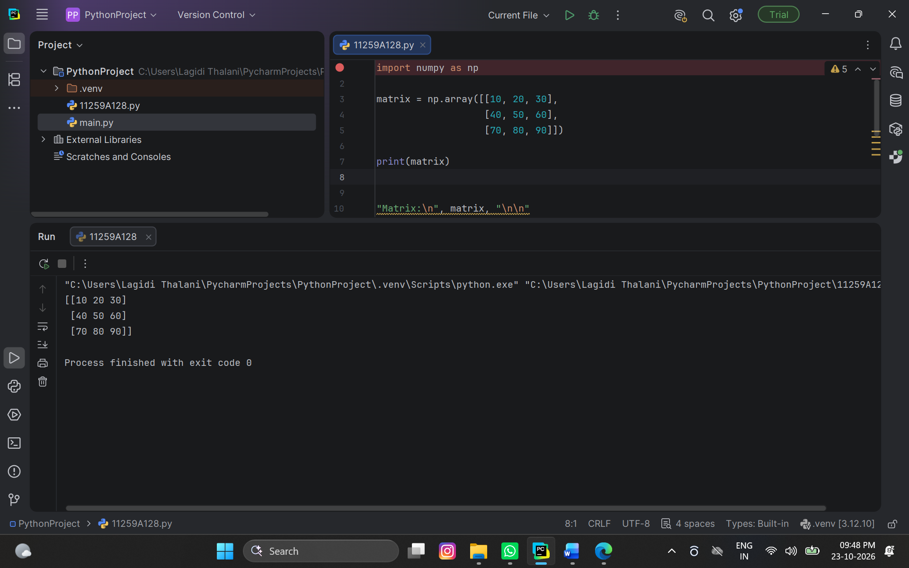

Result
Thus, the dataset was successfully divided into training and testing sets, and the model performance was evaluated using cross-validation.

